1.0 Scope |  |  |  |  | 2.0 Resource Required
- Purpose: Streamline the procedure of Glass pile binding and movement using the EOT crane.  - Area of application: All annealed line EOT crane  - Accountability: HOD annealed packing  - Responsibility: Shift annealing glass-packing line officer |  |  |  |  | 2.1 Man: EOT crane operator and helpers  - Machine: EOT crane  2.3 Material: Annealed glass rack with barcode label, Glass holding clamps, L-shaped cardboard, EVA rubber support and, Belt.
3.0 Terms and Definition |  |  |  |  | 4.0 Key Performance Requirements
3.1 EOT: Electric Overhead Travelling |  |  |  |  | 4.1 Quality: Glass movement using EOT without impacting or compromising the quality of the glass  4.2 EHS: No cut injuries & fall injuries
5.0 Frequency |  |  |  |  | 6.0 Competency Enhancement
5.1 Based on requirement of material movement as per the PPC |  |  |  |  | 6.1. Ensure all operators are familiar with this SOP and have received proper training.  6.2 Only trained and authorized personnel should operate the EOT crane.  6.3 Visual posters to be used for communication.
7.0 Procedure
7.1 Sequence of Operation

7.1.1 Safety precautions:
- Ensure that all personnel involved in the process are wearing appropriate personal protective equipment (PPEs).
- Verify that the EOT crane is in good working condition and has been inspected for safety.
- Verify the belt/sling condition before using it, it should be checked OK by third party.
- Ensure the Rack should have barcode before start moving it.
7.1.3 Clamp fixing in the rack:  - Take the two pieces of the Clamp and make it loose by bolt and nuts.  - Place it over the glass as shown in the picture and ensure the back side rode needs to tie with the rack support. (Ensure that they are evenly spaced for balance support  - Use the nut and bolt mechanism to secure each glass holding clamp in place.  - Ensure that the clamps are tightened firmly but do not over-tighten to avoid damaging the glass.  - Confirm that there is no gap between the glass pile and the EVA rubber support of the clamp. |  |  |  |  |  | 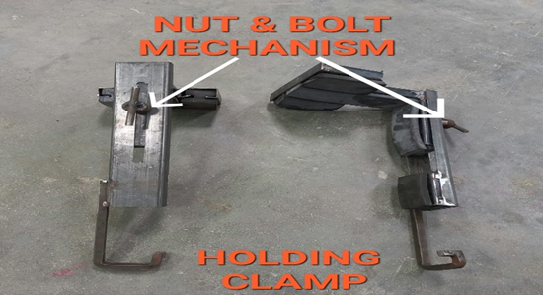  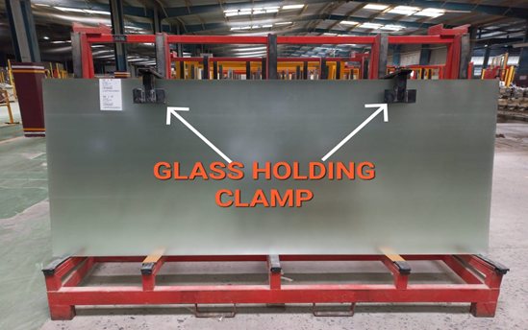  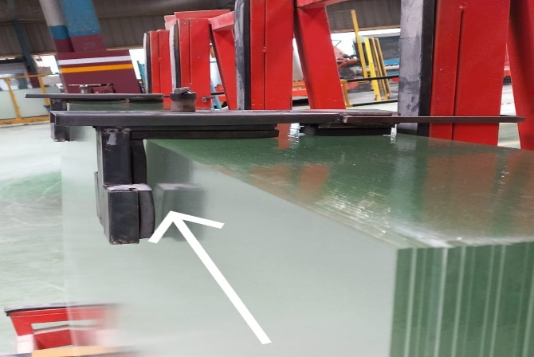
7.1.5 Belt preparation:  - Inspect the belt to ensure it is in good condition and within its usable time frame. Replace if necessary.  - Place the L-shaped cardboard on the glass pile in a way that it provides a flat surface for the belt to rest on. |  |  |  |  |  | 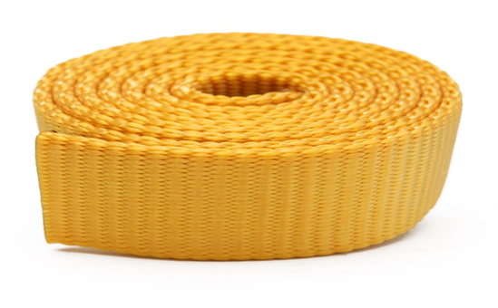  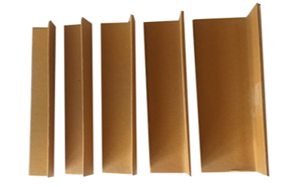
7.1.6 Securing the belt:  - Position the belt around the glass pile.  - Tie the belt securely in such a way that it prevents the glass pile from shaking during the up and down movement by the EOT crane.  Note: Ensure that belts should not be in contact with glass edge directly  - Ensure that the belt is taut but not overly tight to avoid putting unnecessary pressure on the glass. |  |  |  |  |  | 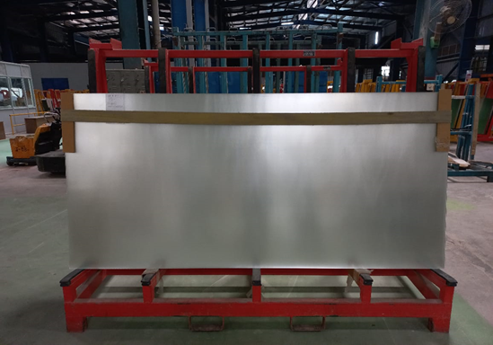
7.1.7. Final inspection:
- Inspect the entire setup to ensure that the glass pile is securely bound with the clamps and belt.
- Confirm that the belt is properly fastened, and the L-shaped cardboard provides stable support.
7.1.8. Material movement:
- If material movement is to be performed using an EOT crane, communicate with the crane operator to ensure safe and smooth operation.
- Ensure that the glass pile remains securely bound during the entire lifting and lowering process.
    - Completion:
- Once the glass pile has been transported or positioned as needed, remove the belt and glass holding clamps carefully.
Store the clamps and belt properly for future use and return them to their designated storage area.
7.2 Special Process Requirements
7.2.1 Not applicable
7.3 Prevention & Detection Controls
7.3.1 Verify the Inspection tag and due date of the belt before using it.
7.4 Controls Related to EHS
7.4.1 PPE MATRIX
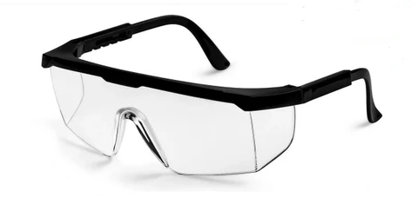 |  | 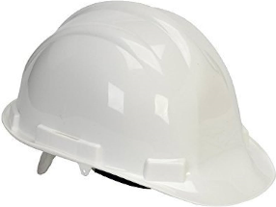 |  | 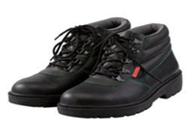 |  |  | 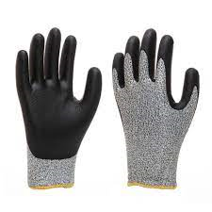
Safety goggles |  | Helmet |  | Safety shoes |  |  | Hand gloves
8.0 EHS Compliance Obligations
8.1 Follow the lifting object guideline as per the EHS guidelines
9.0 Possible deviation & Impacts |  |  |  |  |  | 10. Proposed actions
9.1 Overtight/loose of the belt tied on the pile – chance to fall/break the glass sheet.  9.2 Belt tied on glass edge instead of using L-guard – Chance of glass breakage during handling. |  |  |  |  |  | 10.1 Check the tightness/loose before locking it.  10.2 Always use L-guard and ensure no contact between glass and belt directly.
11. Reference documented information
11.1 Belt inspection report

12. Revision History
Revision No. | Date |  | Description of changes
00 | 01.07.2023 |  | Initial release
01 | 02.12.2025 |  | Format standardized, revision history added, step correction done.

